## **Week 14**

*Written by Konsta:*

This week we had a mid-term presentation and we showed our progress in 3D modelling (mainly done by Aleksi) and in a Tinkercad sketch.

We got some good opinions and tips from supervisors during the presentation.

Week's goal is to continue implementing the code in Tinkercad.

One problem that was raised:

* How can we demo Bluetooth?
* How do we implement the visualization of data that sensors get? (Android or PC)

For each option there is a lot of help on the internet. As we get the Bluetooth module, we could start to test it.

At the end of the week, we got our box of default components (Aleksanteri went to pick them up) .

Goal for the next week is to build Tinkercad circuit design further.

## 

## 

## 

## 

## 

## 

## 

## **Week 15**

*Written by Konsta:*

This week I focused more on coding and building Tinkercad design more further.

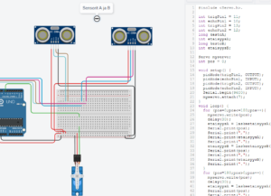

One problem is that it's not possible to test Bluetooth module. We just have to wait for it and test in real life.

The code must take into account how the sensor works. How the distance is calculated.

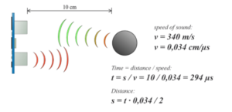

(howtomechatronics.com)

We get the distance when we multiply the speed of sound by the time it takes the sensor to get signal. (Divided by 2 because the signal travels the distance twice.)

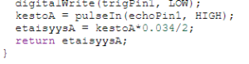

Full sketch of code available at Drive of our project.

Then we also updated the repository to the current situation.

Goal of the week would be to finish sketching and working demo at Tinkercad.

Also to start looking up on the visualization of the data we get from sensors, with Processing IDE and maybe do some coding there.